

American International University- Bangladesh

CSC 3222: Web Technologies

CO1.1 and CO2.1 Evaluation

Project Report

Fall 20-21

Project Title: E-commerce website (For Sports shop)

Section: E

|  |  |
| --- | --- |
| Student Name | Student Id |
| FARIHA, MAHPARA RAHMAN | 17-35900-3 |
| ABDULLAH-AL-HUSSAIN | 18-36085-1 |
| MALLICK, PIA | 18-36104-1 |
| MIM, ILAH JAHAN | 18-36126-1 |

**Introduction:**

E means electronic. Commerce means Business. An E-Commerce website is an information technology method in which traders, businesses/distributors/marketers can sell products/services and the customer can purchase on that website electronically by using the internet on the mobile and computer. It means an e-commerce website is an online shop and we are going to make a website for Sports Shop.

**Background Study:**

**Similar websites:**

Sidelineswap.com

Worldsoccershop.com

SunFrog.com

NFL Merchandise.com

This website is made for a Sports Shop. Sidelineswap.com, Worldsoccershop.com are very similar website. In this website a customer can open an account order product, make payment by card and also there is an admin, some employees and managers who can be the user part of the website.

**Requirement Analysis:**

Four types of user: 1. Admin 2. Manager 3.Customer 4.Employee/Courier

**Common Features for all user:**

1. All users can Login to the system

2. Can register to the system.

3. Can manipulate their profile information (edit-delete-view etc.)

Admin User Functionality:

1. Can add Customer/Manager/Employee.

2. Can verify Customer/Manager/Employee profiles

3. Can manipulate products information (edit-delete-view etc.) etc…

Employee Functionality:

1. Can add product /can publish product

2. Can edit product information

3. Can contact with manager

Customer Functionality:

1. Can buy product/ can make a payment by card

2. Can comment or provide review

3. Can login and registration.

Manager Functionality:

1. Can login and registration.
2. Can contact with Employee.
3. Can contact with Admin.
4. **Feature List:**

1. Admin:

1. Login
2. Logout
3. Add/Update User [Admin, Seller, Employee, Customer]
4. Remove User [Admin, Seller, Employee, Customer]
5. Change Password
6. Profile [Update + View]
7. Add/Update Items
8. Remove an Item from site
9. Maintain Stock
10. Get alert/notification when a product crosses the amount of product in remain stock
11. Manage Offers/Promotions [Decide it]
12. Salary and overtime Generation
13. Registration

**Customer/User:**

1. Registration
2. Login
3. View profile Information
4. Edit profile
5. Upload Profile picture
6. Change Profile Picture
7. Change Password
8. View Product
9. Confirm Order product
10. View Own Order list item
11. View available product
12. Payment
13. Can Post(review product)
14. Logout

**Manager:**

1. Login

2. Password reset

3. Profile [Update + View]

4. View order list

5. Order cancel

6. View customer list

7. Registration

8. View employee list

9. Add employee/remove employee

10. View profile Information

11. Edit profile

12. Upload Profile picture

13. Change Profile Picture

1. Change Password
2. Logout
3. Payment Confirm

**Employee:**

1. Login
2. Registration
3. View profile Information
4. Edit profile
5. Upload Profile picture
6. Change Profile Picture
7. Change Password
8. Show Product
9. Customer List
10. Courier List
11. Order List
12. Can Post
13. Delivery Information
14. Show Salary
15. Logout
16. Contact Customer

**Design:**

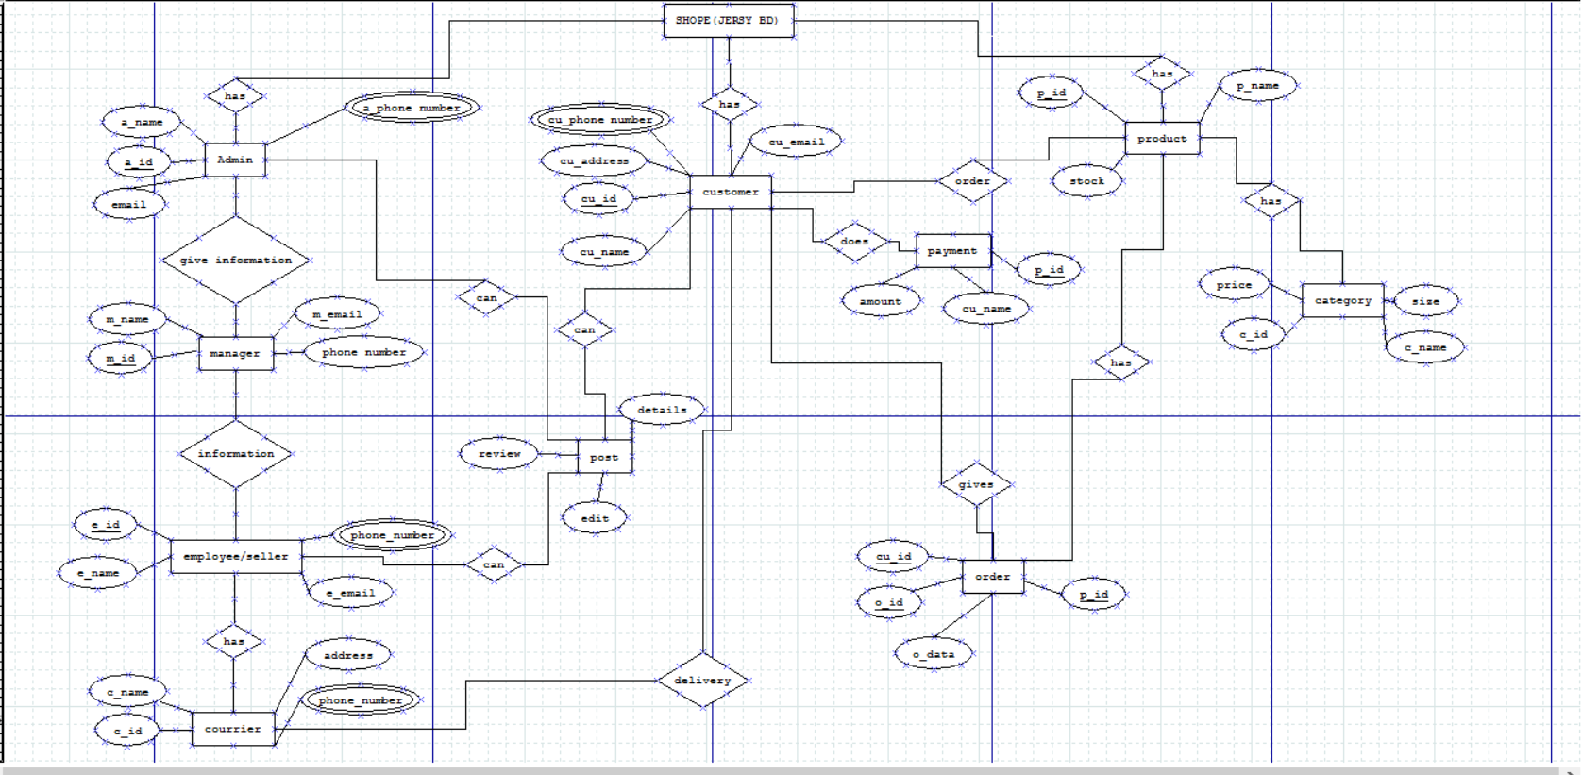

Tools Used:

**To develop this project, we have used the following:**

• Sublime text (Php, Html for coding)

• Notepad++ (Php, Html for coding)

• DIA (For designing diagram)

• Xampp (for server)

• Chrome (for browsing)

• Paint Tools (for edit image)

System Images against the Specification:

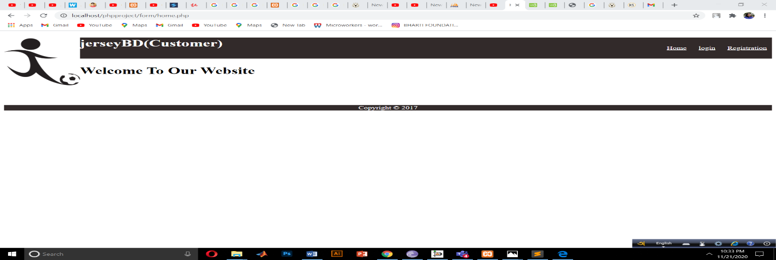

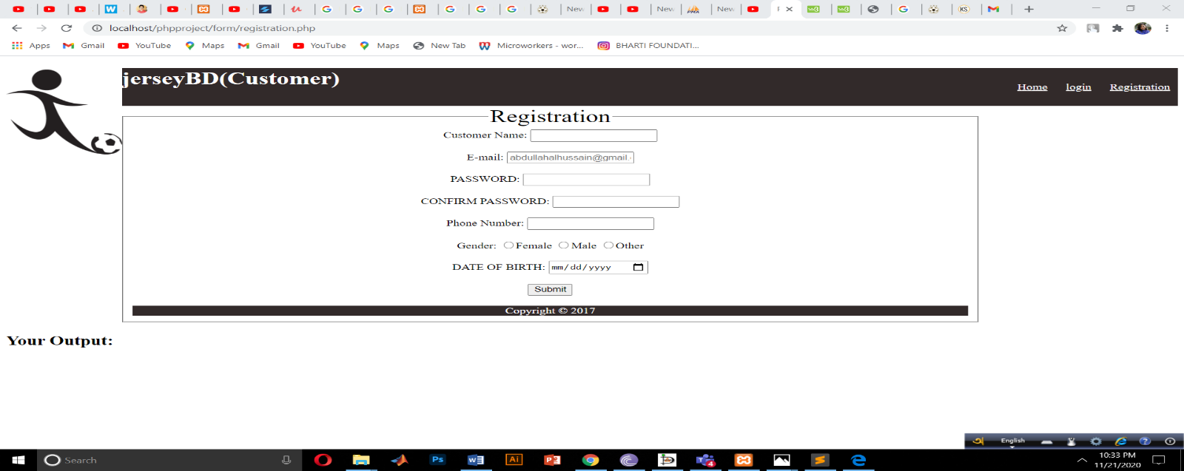  
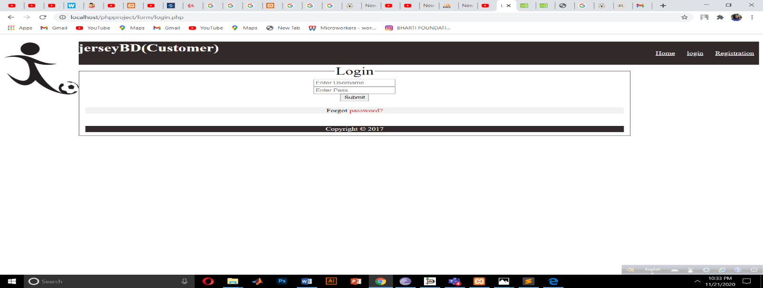

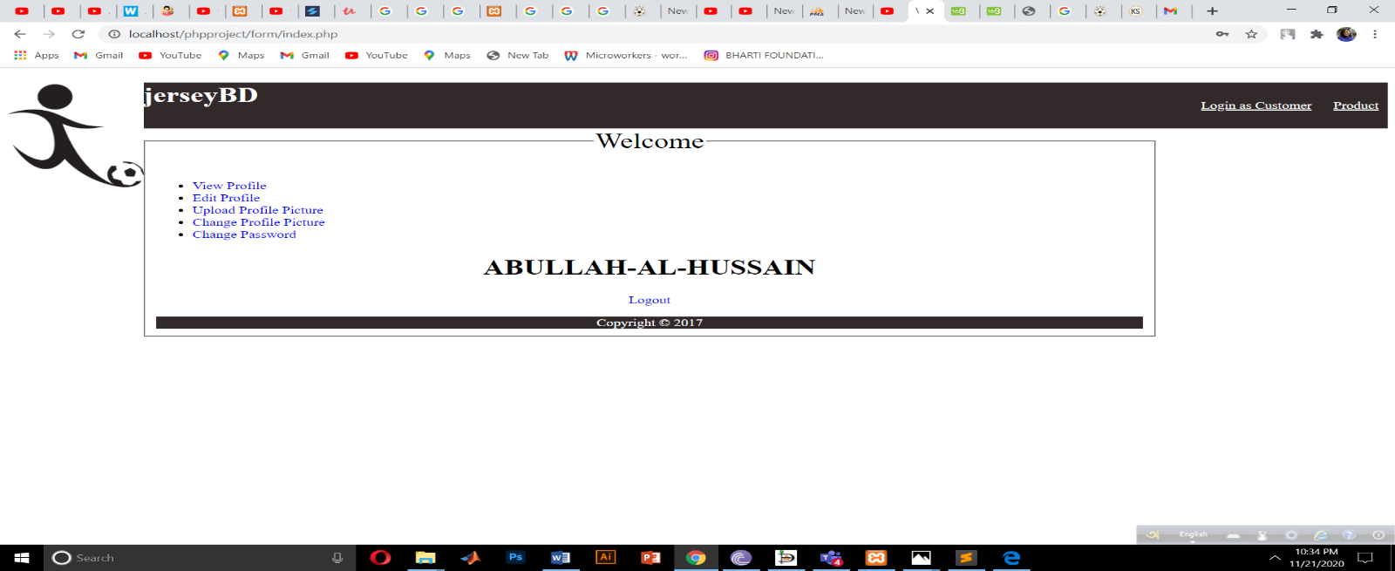

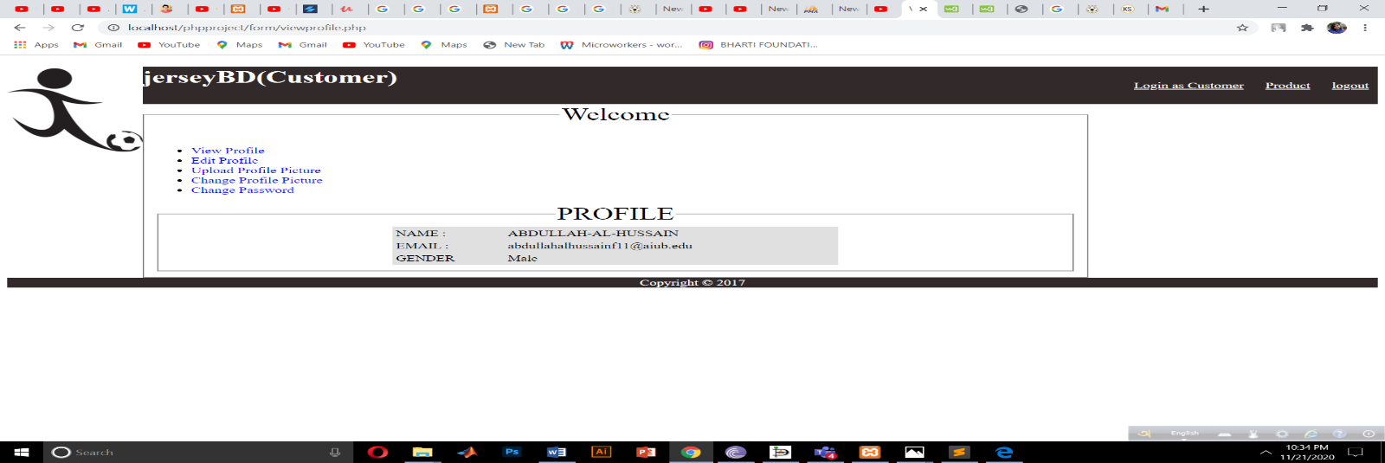

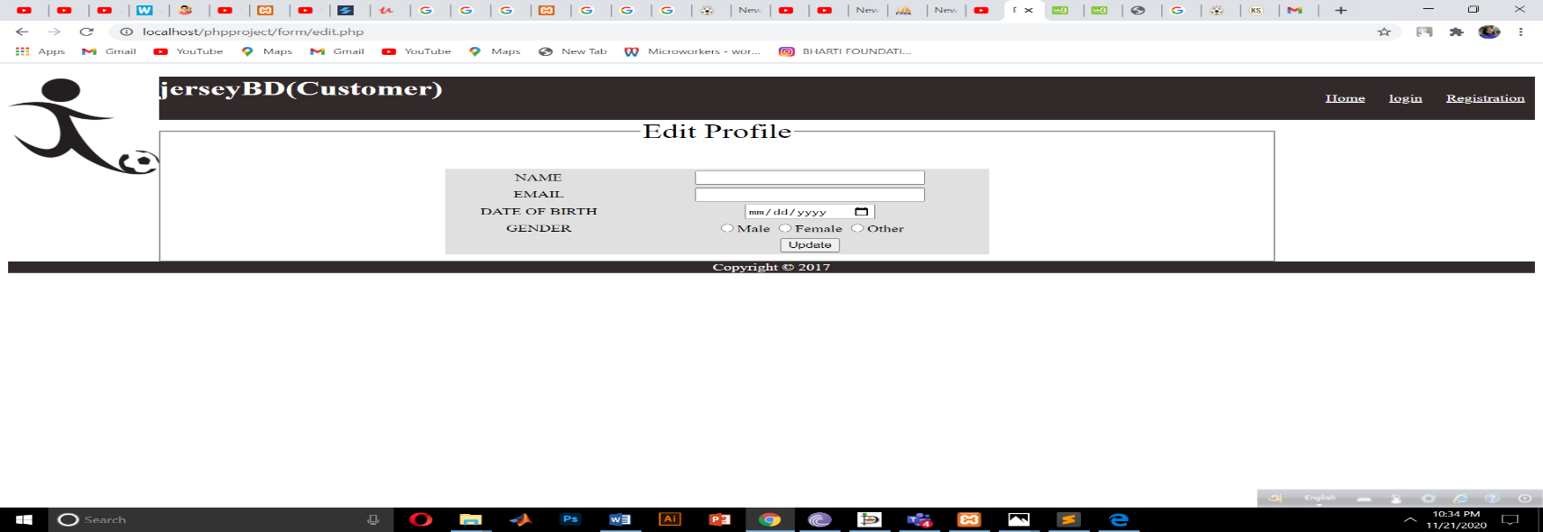

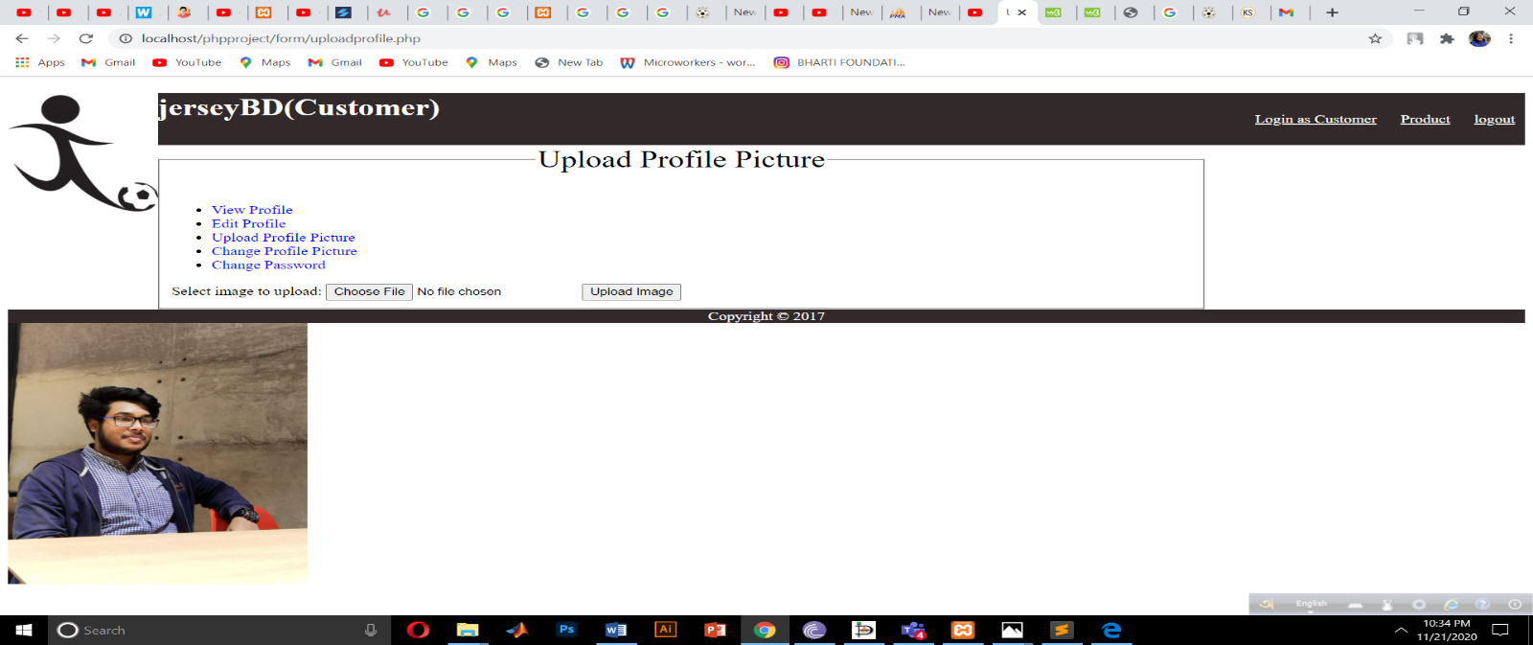

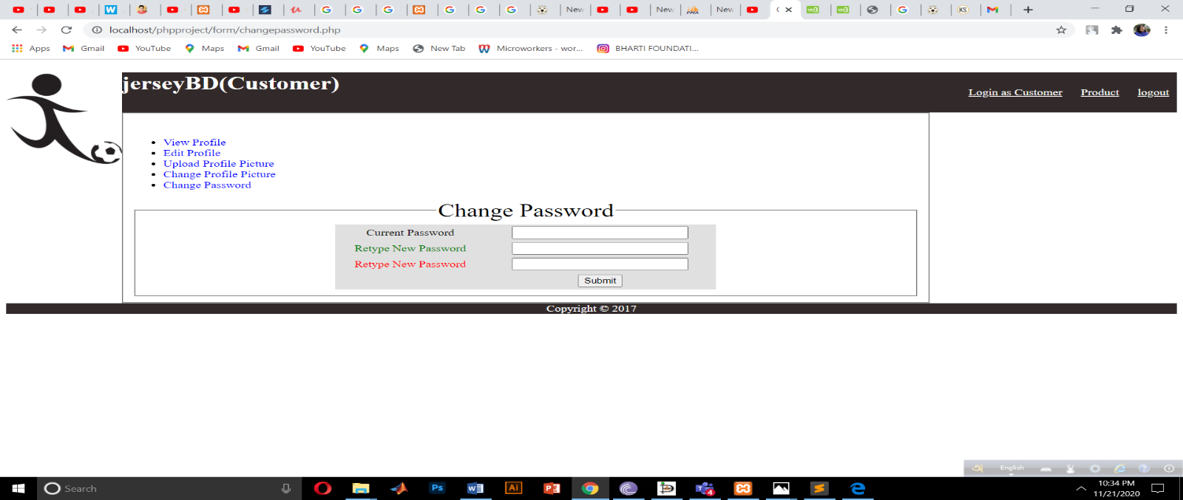

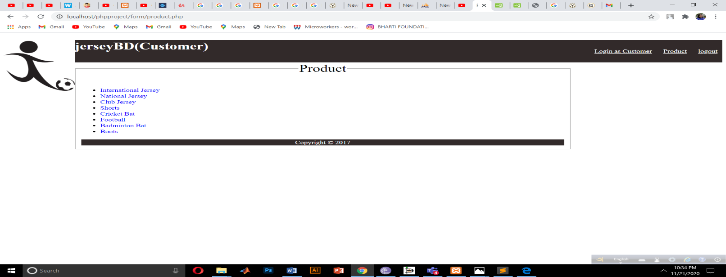

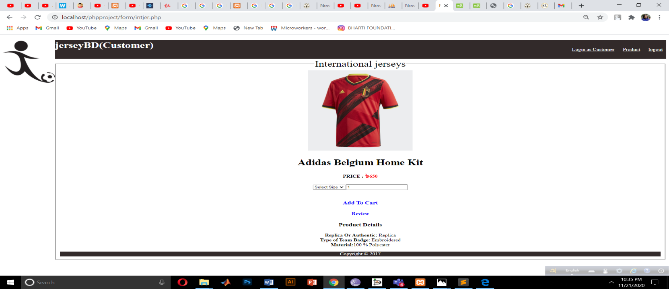

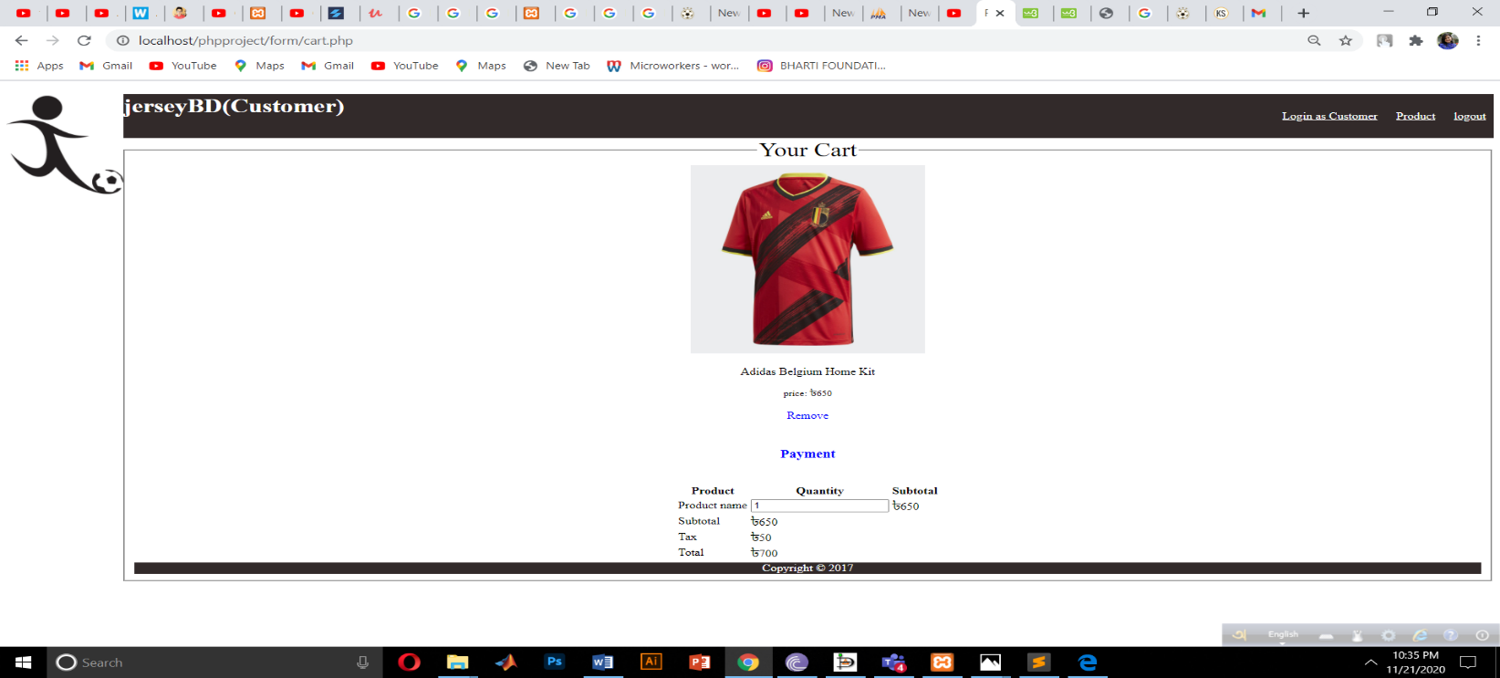

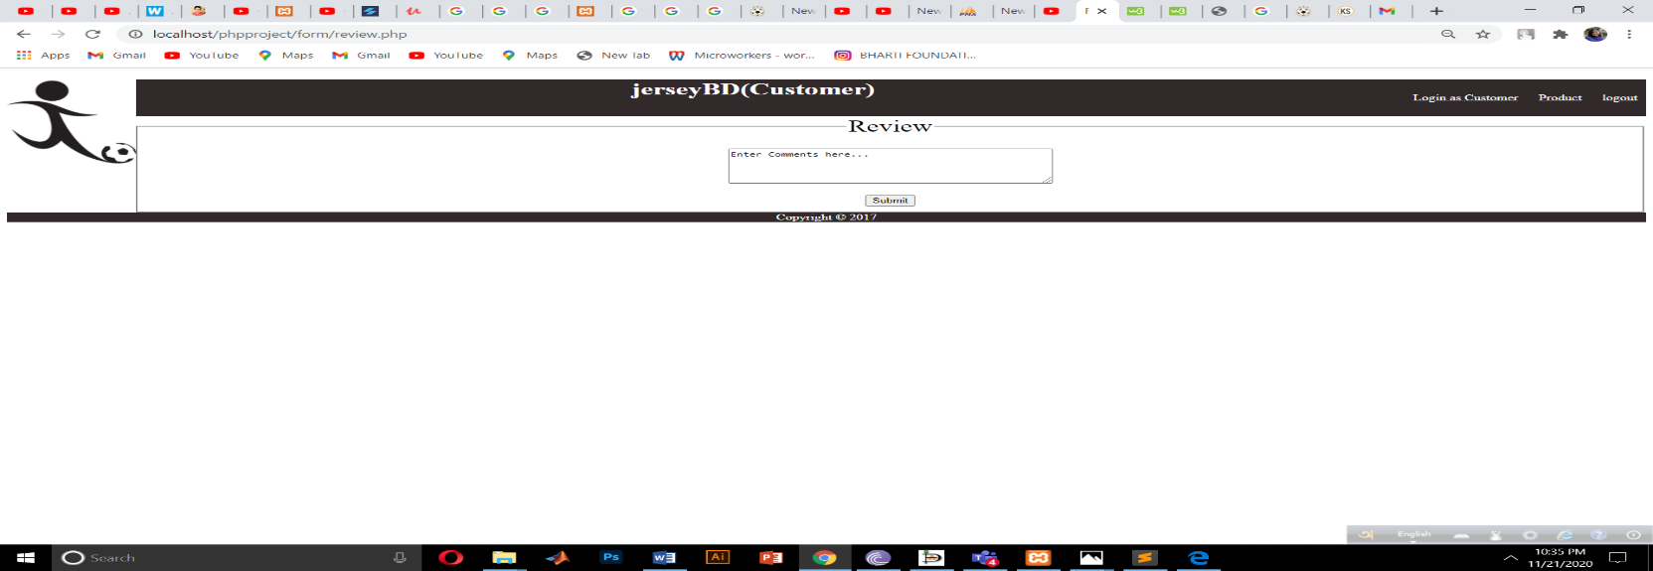

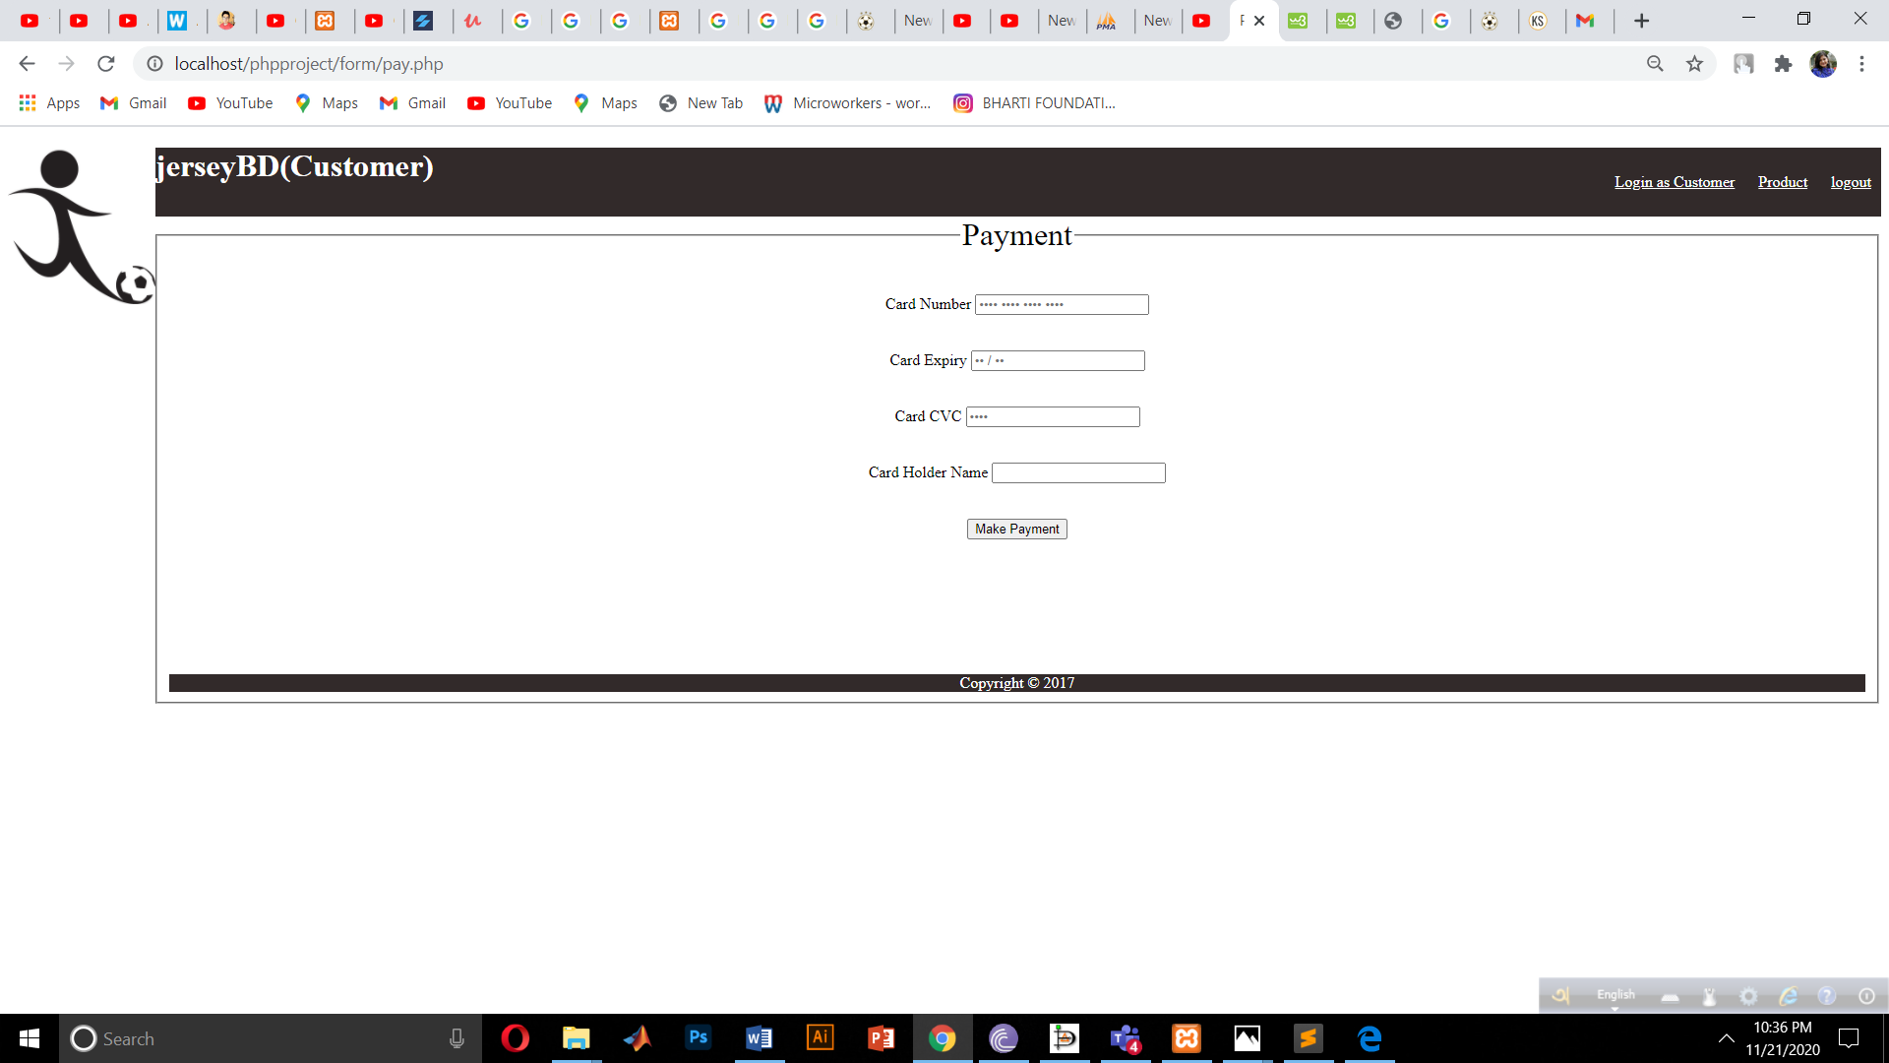

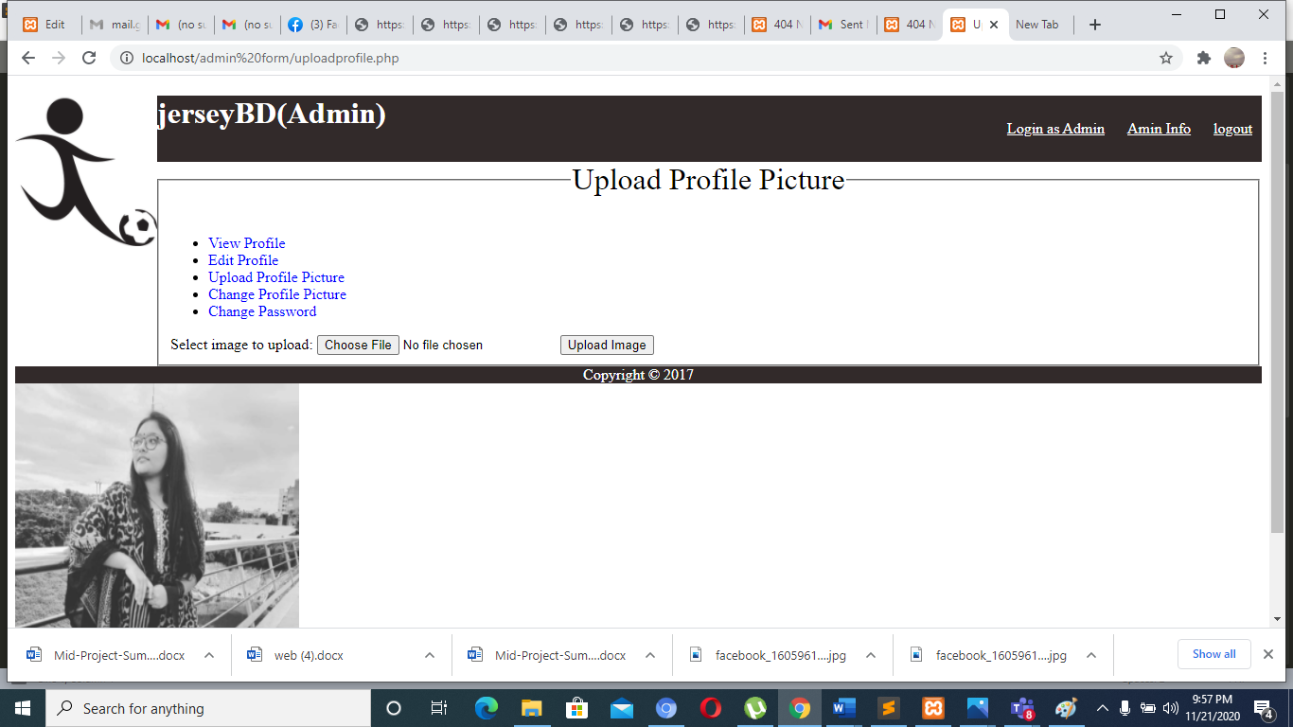

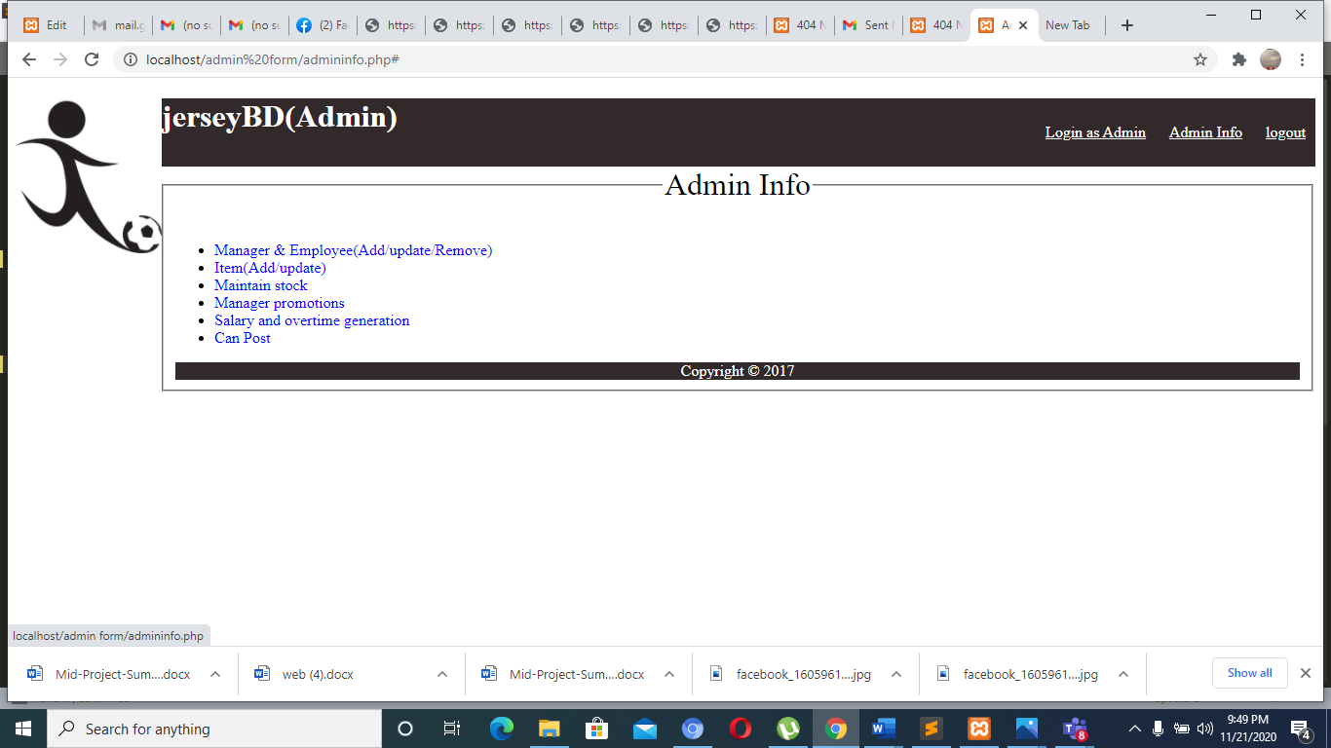

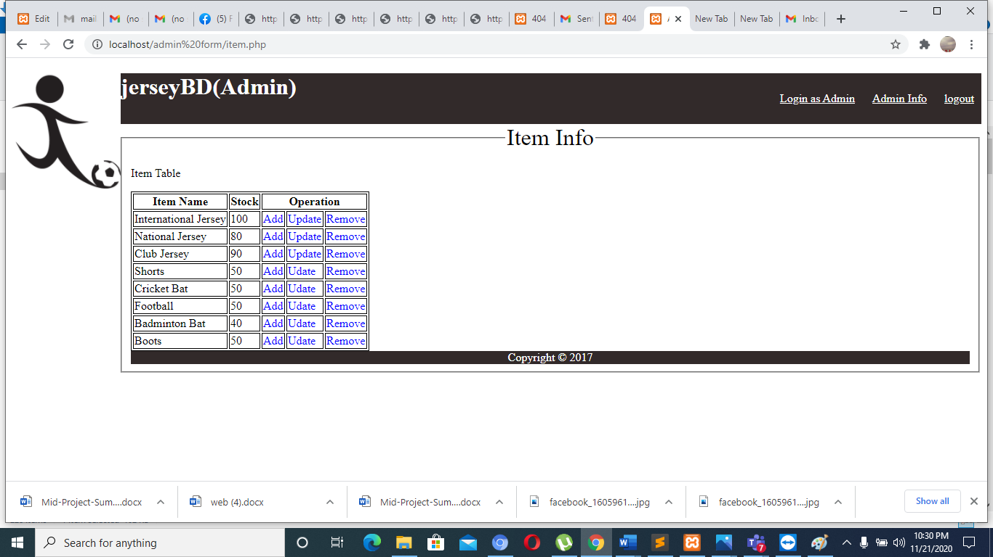

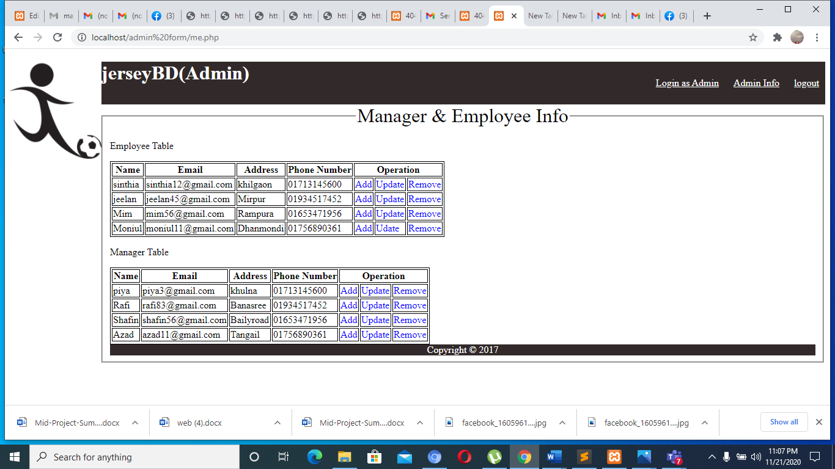

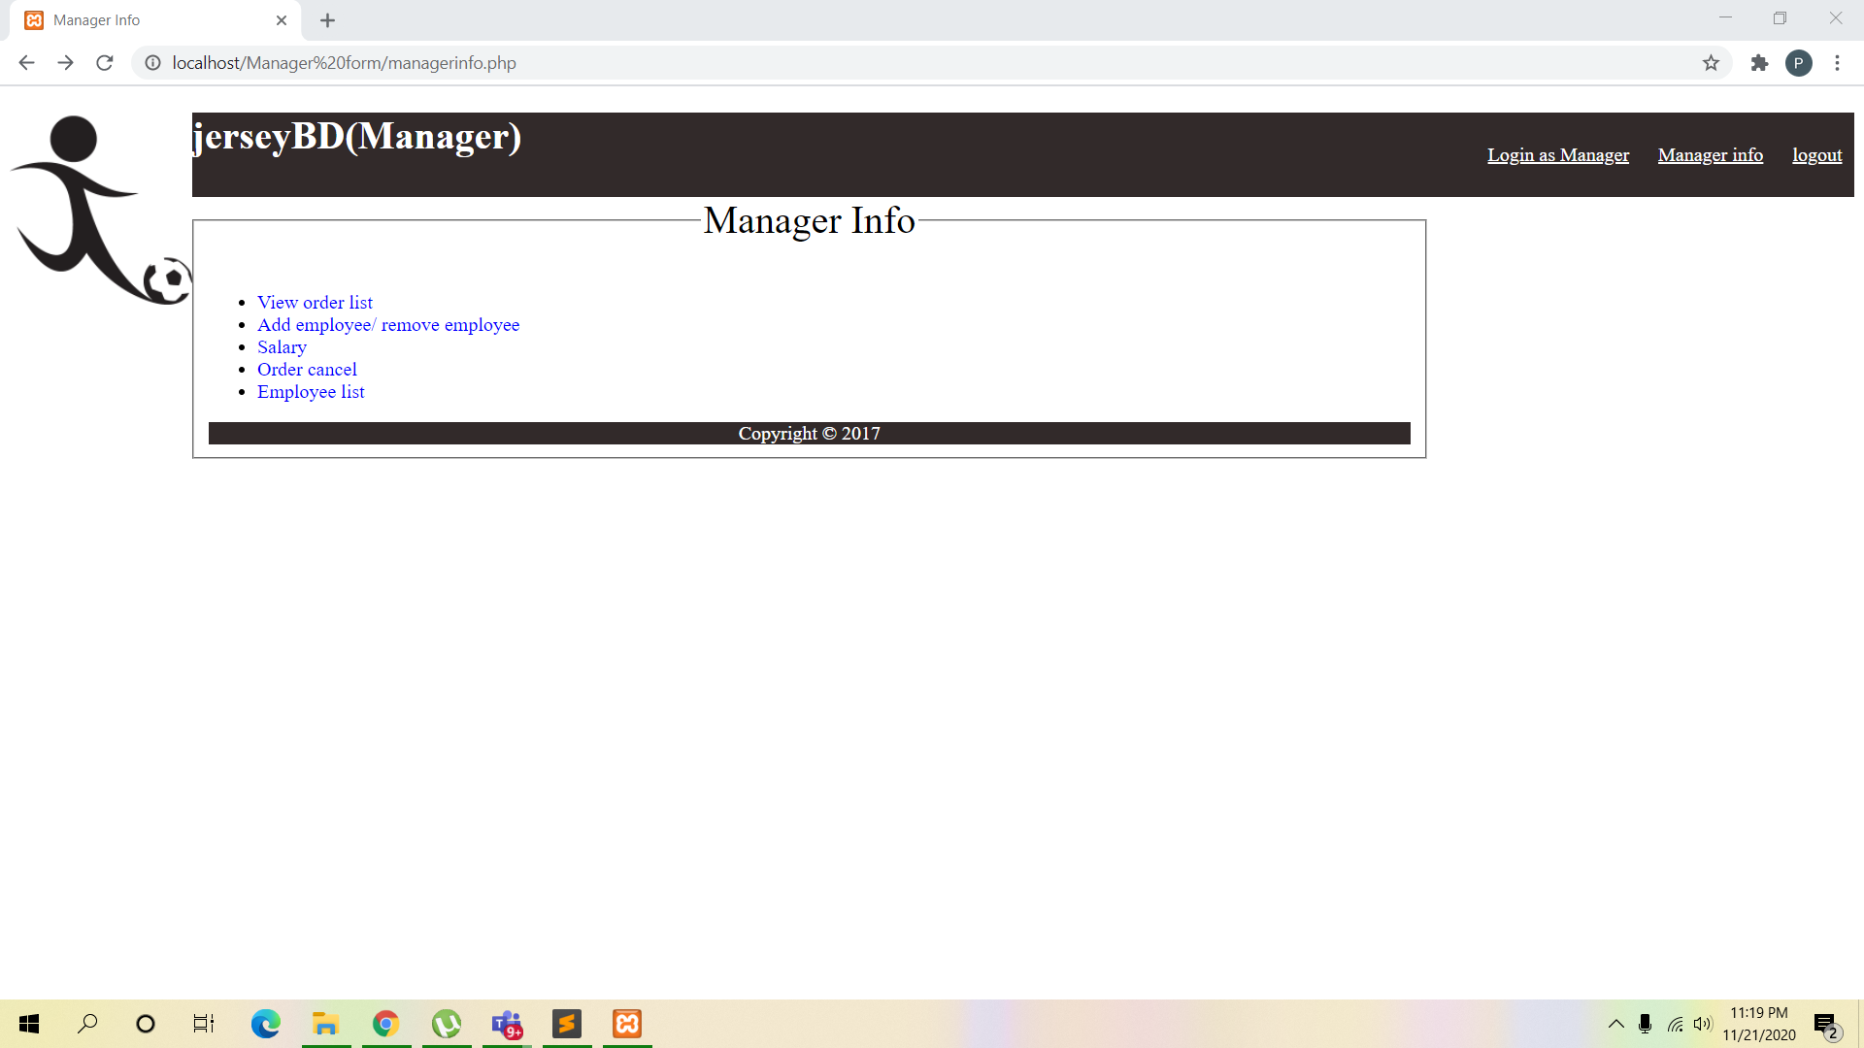

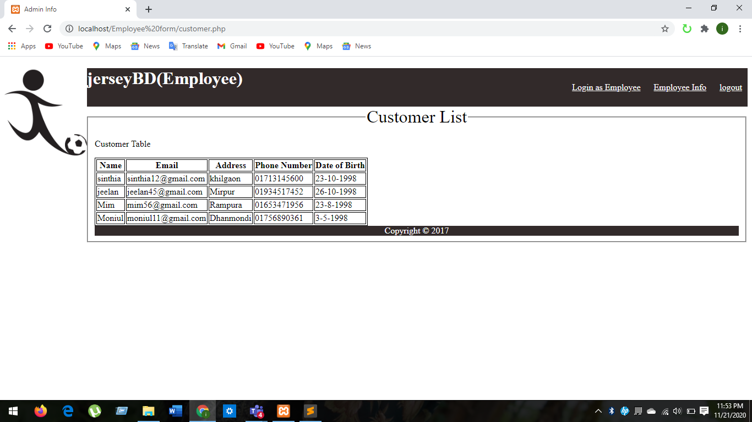

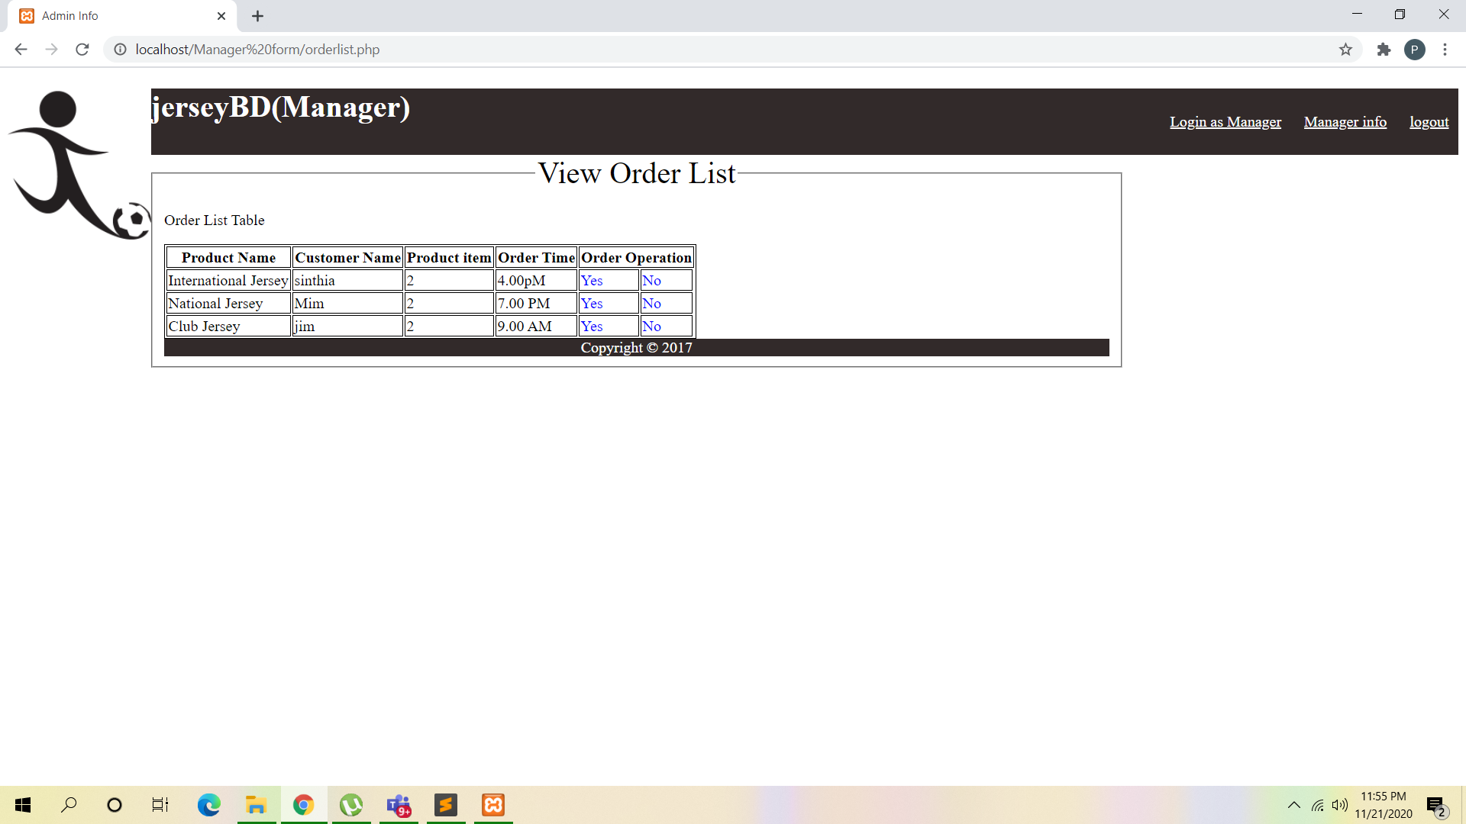

**Impact of this Project:**

Impact of a digital E-commerce website is huge. By using E-commerce website customer can buy product without coming the shop personally. They can pay bills by using carts. So this website is very much time consuming for the customer. Besides that a shop can provide there advertisement and can sell more product by using this website and they can cut a good profit also. So we can say by using this website customer, employee and shop management can be benefited over all.

**Limitations and Possible Future Improvements:**

The main limitation of the website is running in static way. There is not database connection in the website. So everything couldn't be done as per planned. For that reason we cannot deal with dynamic ways. There is also no use of CSS for that reason the website is not decorated very well. If the database connection can added the website will run dynamically and after adding CSS files that will be very much useful website for all.

|  |  |  |  |  |  |
| --- | --- | --- | --- | --- | --- |
| CO1.1 and CO2.1 Evaluation: Project Report Evaluation | | | | | |
| Project Proposal  (5) | Background  Study  (5) | Requirement Analysis  (5) | Entity  Diagram  (5) | System Images  against the  Specification (5) | Total (25) |
|  |  |  |  |  |  |
|  | | | | | |